**Computer**

**Network**

**Class Six**

**Lab 6**

|  |
| --- |
| Lab Objectives:Twisted pared cableCo-axial cableOptical fiber |

# Networking Cables

## Networking cables are networking hardware used to connect one network device to other network devices or to connect two or more computers to share printers, scanners etc.

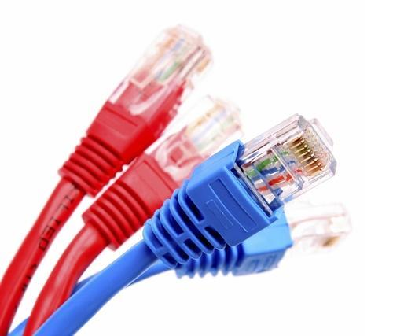

# Types of Networking Cables

## Twisted pared cable

## Co-axial cable

## Optical fiber

# Twisted pared cable

## Twisted pair cables are quite literally a pair of insulated wires that are twisted together to help reduce noise from outside sources.

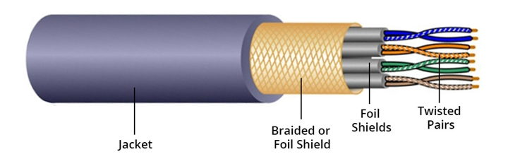

## A pair of wires forms a circuit that can transmit data. And the pairs are twisted together to provide protection against crosstalk

# Coaxial Cables

## Coaxial cables are high-frequency transmission cables made up of a single solid-copper core. Data is transferred electrically over the inner conductor and has 80X more transmission capacity than twisted pair cables.

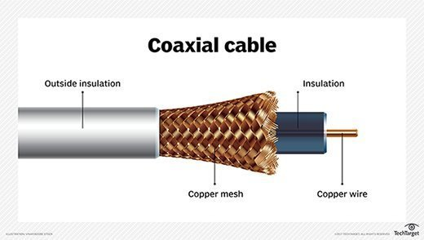

# Fiber Optic Cables

## Fiber is the newest form of  transmission cable technology. Instead of transferring data over copper

## wires, these cables via light, rather than pulses of electricity.

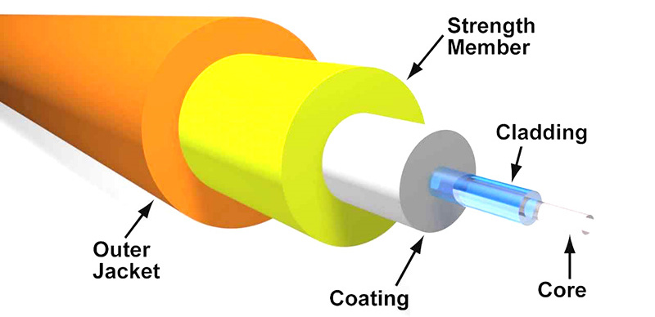

## Fiber optic cable transmits data as pulses of light go through tiny tubes of glass. The transmission capacity of optical fiber cable is 26,000 times higher than that of twisted pair cable.

# Fiber Optic Cable vs Twisted Pair Cable vs Coaxial Cable: What’s the Difference?

## Except for the construction differences of fiber optic cable vs twisted pair cable vs coaxial cable, these three types of cables distinguish from each other in cable performance and capacity.

# Speed, Bandwidth & Distance

## Coaxial cable and twisted pair cable are copper or copper-based wire surrounded by insulation with other materials.

## Both of them can transmit television, telephone and data with electrical signals. While fiber optic cable can deliver the same types of signals with much wider bandwidth, faster speed and higher frequencies. It’s made of very thin, pliable tubes of glass or plastic.

|  |  |  |  |
| --- | --- | --- | --- |
| **Cable Type** | **Speed** | **Bandwidth** | **Distance** |
| Fiber optic cable | 10/100/1000Mbps, 10/40/100/200Gbps | Up to 4700MHz | Up to 80km |
| Twisted pair cable | Up to 10Gbps | Up to 4700MHz | Up to 100m |
| Coaxial cable | — | 750MHz (default) | Up to 500m |

# Wireless

## Wireless communication, or sometimes simply wireless, is the transfer of information or power between two or more points that are not connected by an electrical conductor.

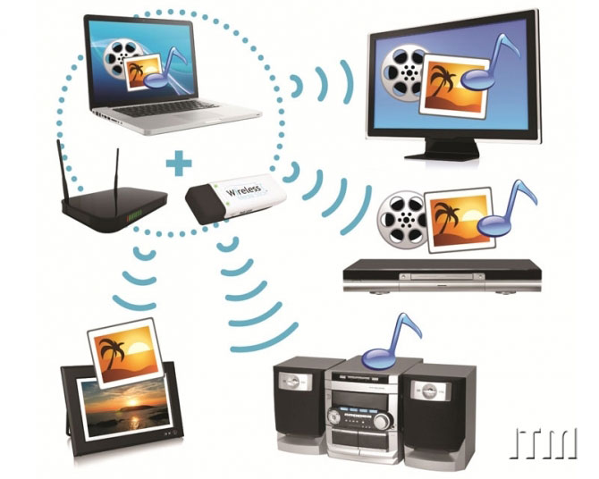

# What is a satellite?

An object in an orbit is called a satellite. A satellite can be natural, like the Moon, or human made. Satellites can travel around planets or around stars such as our Sun.

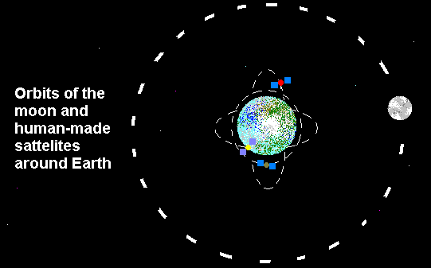

## All the planets are satellites around the Sun. Almost every ship launched from Earth can be considered a satellite, as it is orbiting either the Earth or the Sun.

